**FEDERATED LEARNING-BASED 3D MEDICAL IMAGE COMPRESSION**

**ABSTRACT:**

This project presents a **Federated Learning-Based 3D Medical Image Compression** system that combines **Optimal Multi-linear Singular Value Decomposition (OMLSVD)** and **deep auto-encoders** to compress 3D medical images with minimal quality loss. Traditional compression methods like JPEG2000 reduce image quality after decompression, while our method ensures high fidelity and reduced storage. To preserve data privacy, **Federated Learning** is used—each medical client trains a local model and shares only the weights with a global server, avoiding direct data sharing. The system is tested on a 3D chest X-ray dataset and shows improved performance in terms of **SSIM**, **PSNR**, and storage size. Results confirm that the proposed method offers better compression, high-quality decompression, and privacy-preserving collaboration across clients.

**EXISTING SYSTEM:**  
Traditional 3D medical image compression techniques such as PCA, Discrete Wavelet Transform (DWT), and JPEG2000 are commonly used to reduce storage requirements. However, these methods often lead to significant loss in image quality upon decompression, which is critical in medical diagnostics. Furthermore, when deep learning methods like auto-encoders are used for compression, they require centralized data training, raising privacy concerns, especially when sensitive patient data from multiple medical institutions are involved.

**PROPOSED SYSTEM:**  
The proposed system introduces a hybrid compression approach using **Optimal Multi-linear Singular Value Decomposition (OMLSVD)** along with **deep auto-encoders** to achieve high-quality 3D medical image compression with lower storage usage. To address privacy concerns, **Federated Learning** is integrated, allowing multiple medical clients to train models locally and share only the model weights with a centralized federated server. This ensures data privacy while enabling collaborative learning. The system significantly improves decompressed image quality (in terms of SSIM and PSNR) and reduces storage, making it suitable for secure, scalable medical image management.

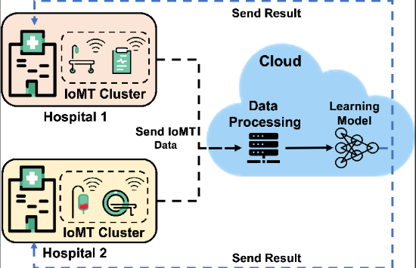

**SYSTEM REQUIREMENTS:**

**HARDWARE REQUIREMENTS:**

* Hard Disk  :   40 GB.
* Ram    :   512 MB.

**SOFTWARE REQUIREMENTS:**

* Operating system   : Windows 7
* Coding Language  : pythoncksbcjiagdjbka